Report of Gill Miller’s presentation 8th Sept 2015
Post 15 Agenda: Sustainable Development Goals
17 goals and 169 targets
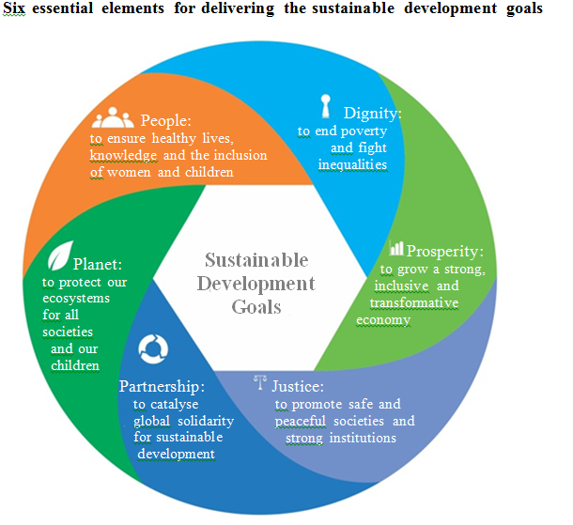
Source: UN 2014 A/69/700 Synthesis report of the Secretary-General on the post-2015 sustainable development agenda p16
UN signing up to these at end of Sept. Has taken 3 years of discussion, including an on- line questionnaire to which 4 billion responded. http://vote.myworld2015.org/.

5 underlining principles:
- Leave no one behind – the MDGs aimed to reduce the number of people living in poverty by half. SDGs refer to everybody – the marginalised, the vulnerable
- Sustainable development at the centre
- Transform economies for jobs and inclusive growth – how to finance jobs and thereby improve quality of life
- Build peace and effective institutions – how the institutions are run to benefit all
- Global partnership – goals apply to everyone

People are looking for UN leadership – Key Question: Is the UN fit for purpose?
There are 3 ‘arms’ to UN consultations and decision-making – the countries (General Assembly), The Secretariat, and the NGOs and big corporations. Observers are asking how will the UN incorporate all of these?
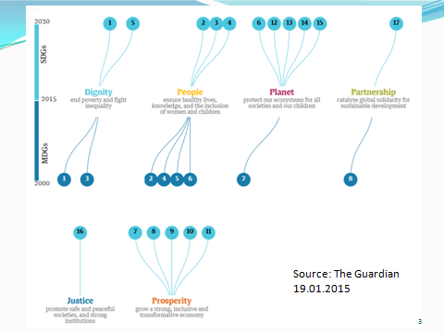

This slide shows how the new SDGs match with the MDGs. With the MDGs there were 8 clear goals. The new SDGs have 17 goals and 169 targets.

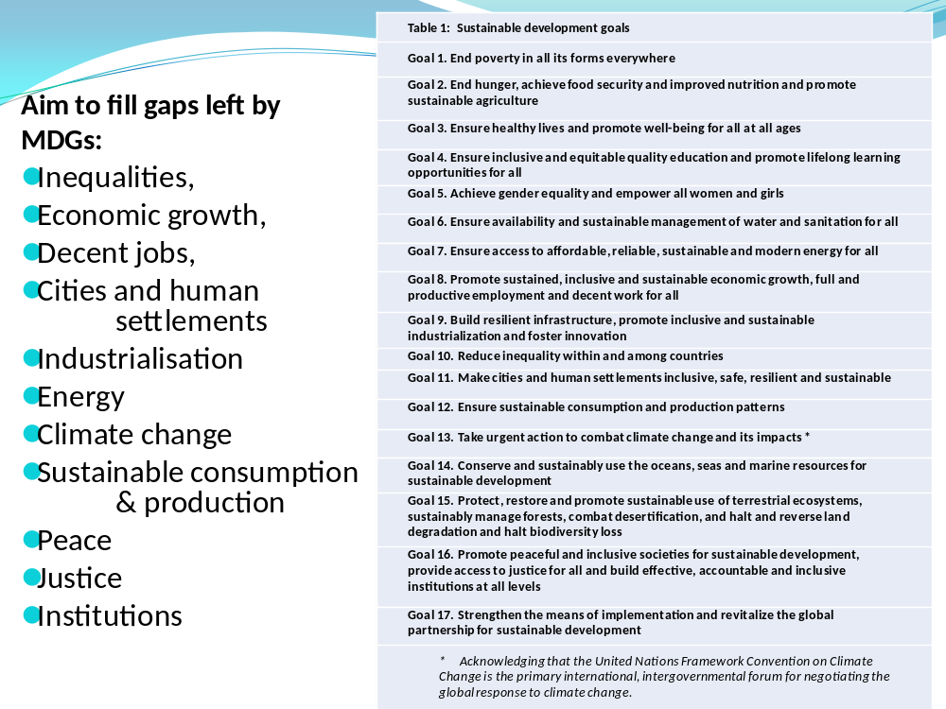
SDGs are aspirational and global.
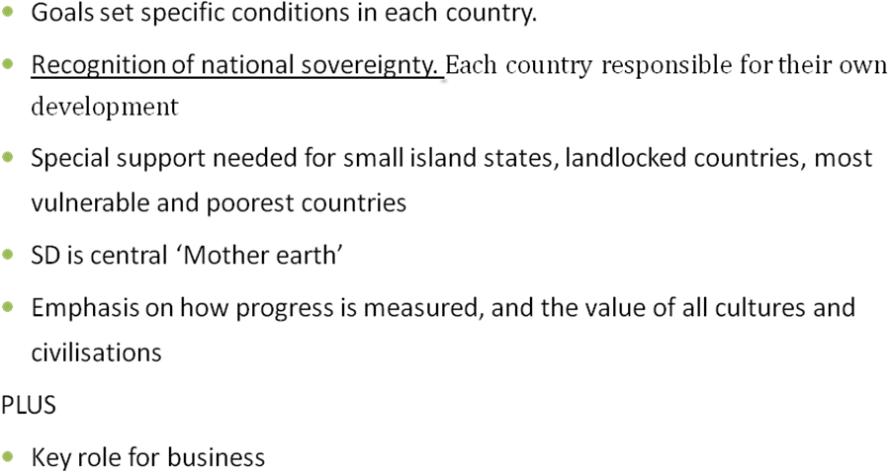
Key question: How do we measure progress? How will we measure progress? What could we use as indicators? Many questions have been raised as a result of the experience of the MDGs. The collection of data is expensive and needs to be done at the beginning and at the end. Poor countries are not going to have this data or the means by which to collect it. And how do we measure different cultures?

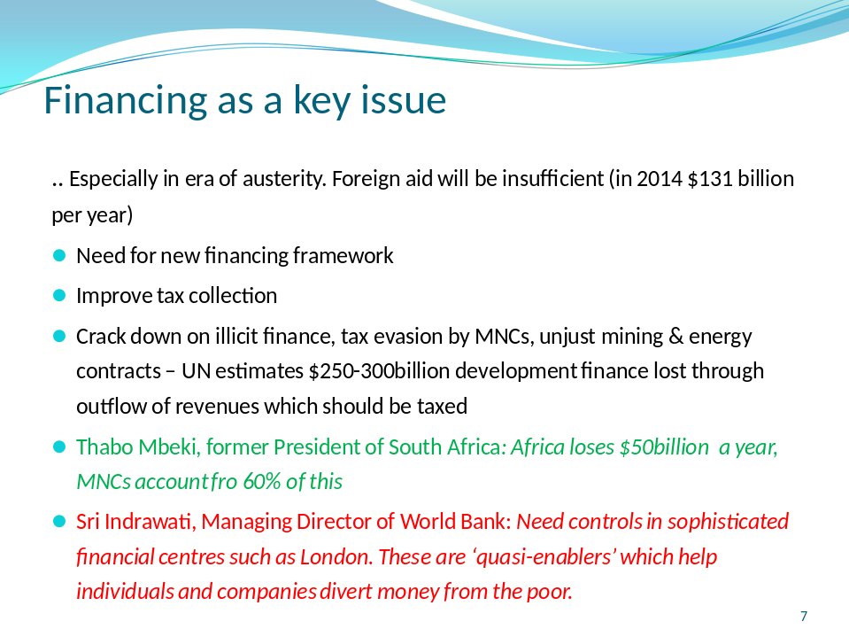

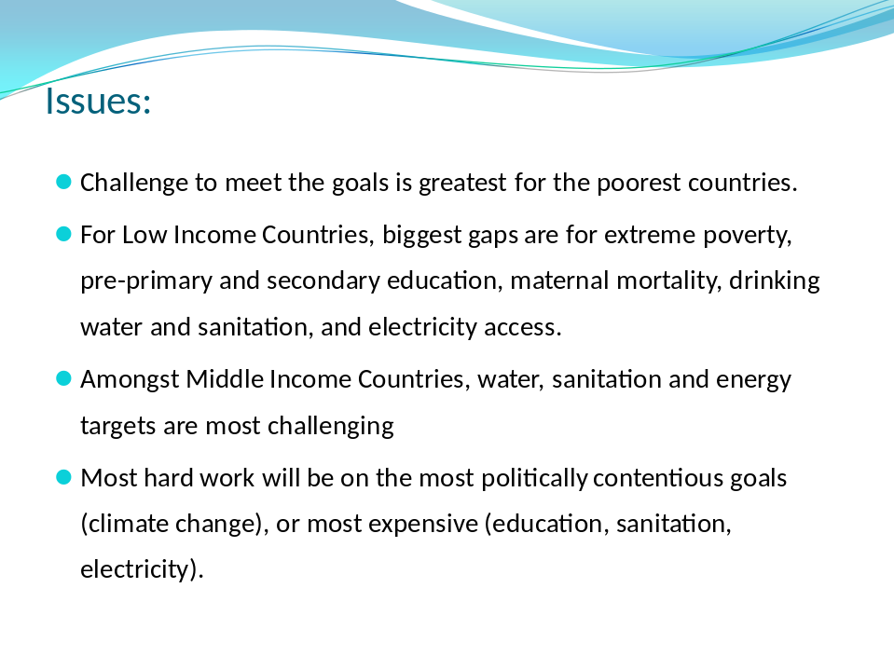
Key Questions/comments:
Poorest countries have furthest to go to reach the new goals. They start from the poorest levels of each indicator. And often have the weakest governance and finance to make progress.
Re education: There have been improvements in enrolment with more children in school but there are now concerns about the quality of education.
Re sanitation – providing toilets is not enough. Eg In South Africa, there is a cultural attitude to be overcome in getting some people to use toilets. Need to change hearts and minds
Key issue will be climate change. Need to have positive outcomes from Paris Summit in Dec on climate change - without this SDGs not possible
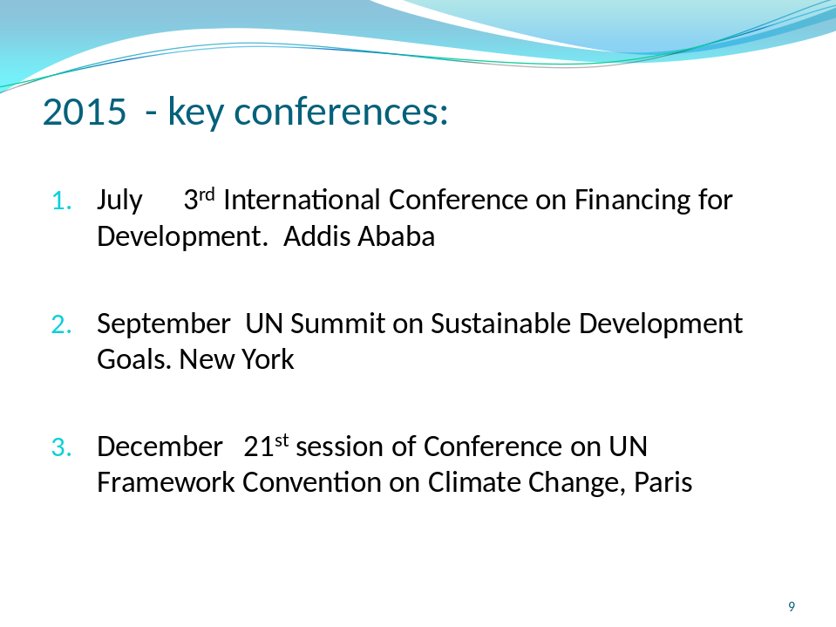

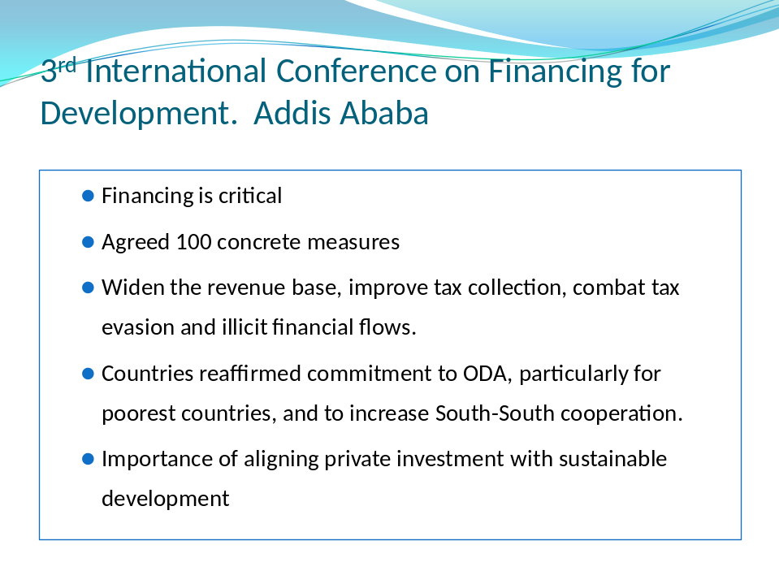
Comments: Comments: Financing for the SDGs is a key issue. At present, complicated financial instruments use “creative accounting” to move funds around the world. These make it very difficult to follow where the money goes, but there is clear evidence that money ends up being from the poor.
Another important question: What does ODA now consist of? DFiD is moving to more corporate finance/supporting businesses and away from just international assistance. There is an increased emphasis on the private sector and a move to “financializing” development. DFiD working to improve financial institutions in poor countries so that they can create their own financial sector and financial ‘instruments’. DFiD is partnering the UK Stock Exchange, for instance, to work in Tanzania so that government can set up their own financial sector and generate more income. Developing countries need robust financial institutions so that they can, for instance, pay teachers.

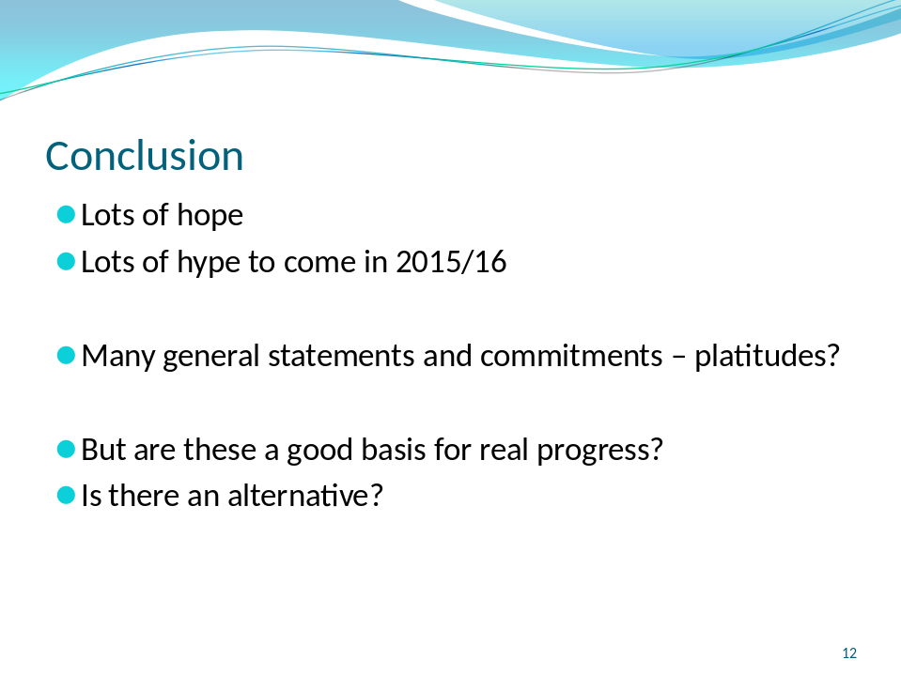

Key Questions:
- Are the SDGs the way forward? Some MDG, such as poverty reduction targets, were achieved largely because of progress in China, and contributions by Chinese investments in African countries.
- Are the SDGs so ambitious that nothing will be achieved?
- Whose agenda is it? Rich countries are still in the driving seat
- Could be driven by finance but global financing so complex

Comments from those present:
AC: “Health 20/20” agenda needs to be followed – clearly would improve life in general. Also made the point – which more useful, spending money on collecting data or on improving sanitation
BP: Expressed concern that very little reporting in the press on SDGs – been crowded out by other issues. Referred back to Agenda 21 – main documents unmanageable. SDGs document also too elaborate. Countries need to concentrate on just some of the goals
KS: Commented on the tax issue – good that problem is recognised. Has been some movement on challenging companies. At least issue more out in the open now
GM: Culture/gender issues – in some areas, such as rural Kenya, men don’t allow women to go for ante-natal checks because they have to have test for HIV. Problems with UN – not a strong organisation with limited clout to enforce strategies which will lead to progress.

