This last year has been busy, varied, and successful. The Forum’s meetings, since the May 2009 AGM, have all been at the Quaker Meeting House, apart from the September meeting, which was held at St Peter’s Centre.

CHESTER WORLD DEVELOPMENT FORUM

REPORT ON 2009-2010 ACTIVITIES

Our regular Forum meetings have included presentations on a wide range of subjects:

- July 2009: Work with street children in Brazil, speaker Nell Mann
- September 2009: Focus on Sierra Leone, speakers Christine Russell MP, Heather Lannin and Cath McNicholls
- November 2009: The work of Amnesty International, speaker Patsy Bradbury of Chester Amnesty Group
- January 2010: The work of Global Inclusion and the “City of Sanctuary” initiative, speaker Dr Joseph O’Neill
- March 2010: Follow-up discussion on the “City of Sanctuary” initiative.
Throughout the year our work and cooperation with the University of Chester’s Department of Geography and Development Studies has continued and strengthened, to our mutual advantage:

- We actively supported and publicised a lecture arranged by the University, “Can we prevent climate change and make poverty history?” with an excellent speaker, Duncan Green of Oxfam.

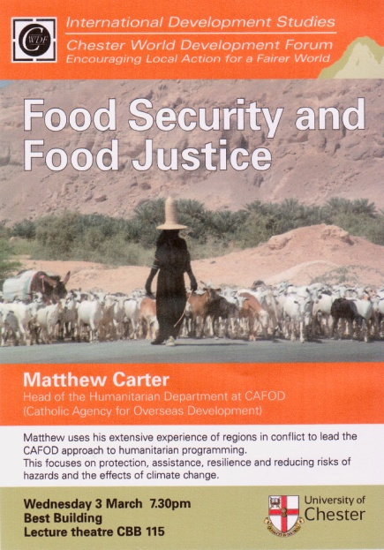
- As an initiative for Fairtrade Fortnight we organised at the University a lecture on “Food Security and Food Justice”. The speaker was Matthew Carter, Head of Humanitarian Assistance department at CAFOD.

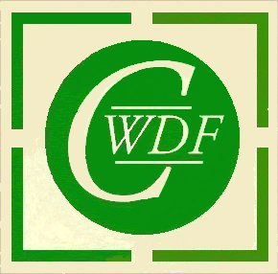
Both events were held in Best Building at the University, and excellent venue for larger meetings. Thanks once again to Gill Miller, Programme Leader for International Development Studies at the University (and CWDF member) for her support and professionalism. For their part, the Department of Geography and Development Studies appreciates the Forum’s extensive mailing and network contacts as a means of reaching out into the community.

The major concern in international development issues in 2009-10 has been climate change. Increasingly, people are realising that “we are all in this together”, and increasingly aware that it is the poorest people in the poorest countries who will be most affected by climate change.
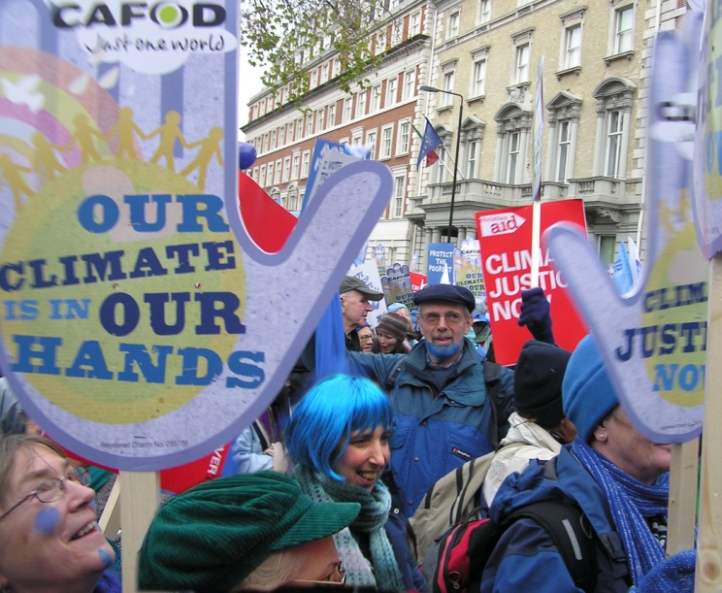
CWDF took a coach to London on 5th December to join “The Wave” march. This march was intended to underline the strength of public feeling in the immediate run-up to the UN climate summit in Copenhagen.

Once again CWDF played a significant part in Fairtrade Fortnight (February 22nd – March 6th ). Forum members serve on the Cheshire West and Chester Council’s Fairtrade Steering Group and were pleased that the new Council has declared its commitment to being a Fairtrade Council. The challenge next year will be to organise Fairtrade events over a much larger area, incorporating the 3 previous authorities.
Start of “The Wave” March, 5th December 2009
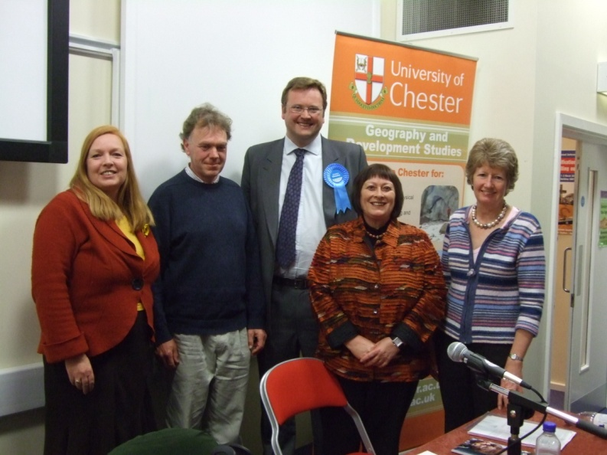
During the General Election campaign period CWDF took the initiative in organising a pre-election Question Time on International Development; we considered that it was unlikely that the main hustings meeting would be giving detailed attention to international development issues. This took place in the Best Building, involving 4 candidates (Conservative, Green, Labour, LibDem) and Gill Miller in the chair. It was attended by 70+ people and proved an informative evening.
16th April 2010: Pre-election Q&A session with Parliamentary Candidates Elizabeth Jewkes, Tom Barker, Stephen Mosley and Christine Russell. Session chaired by Gill Miller

Many challenges face us in next year’s programme. We wait to see how much attention will be given to climate change and world poverty. It will be interesting to see how the incoming government deals with these issues, which are of prime concern to CWDF members. And, of course, it will be important to maintain dialogue with the elected MP for the City of Chester.

Kath Stephenson

Bernard Payne
www.chesterwdf.org.uk May 2010

